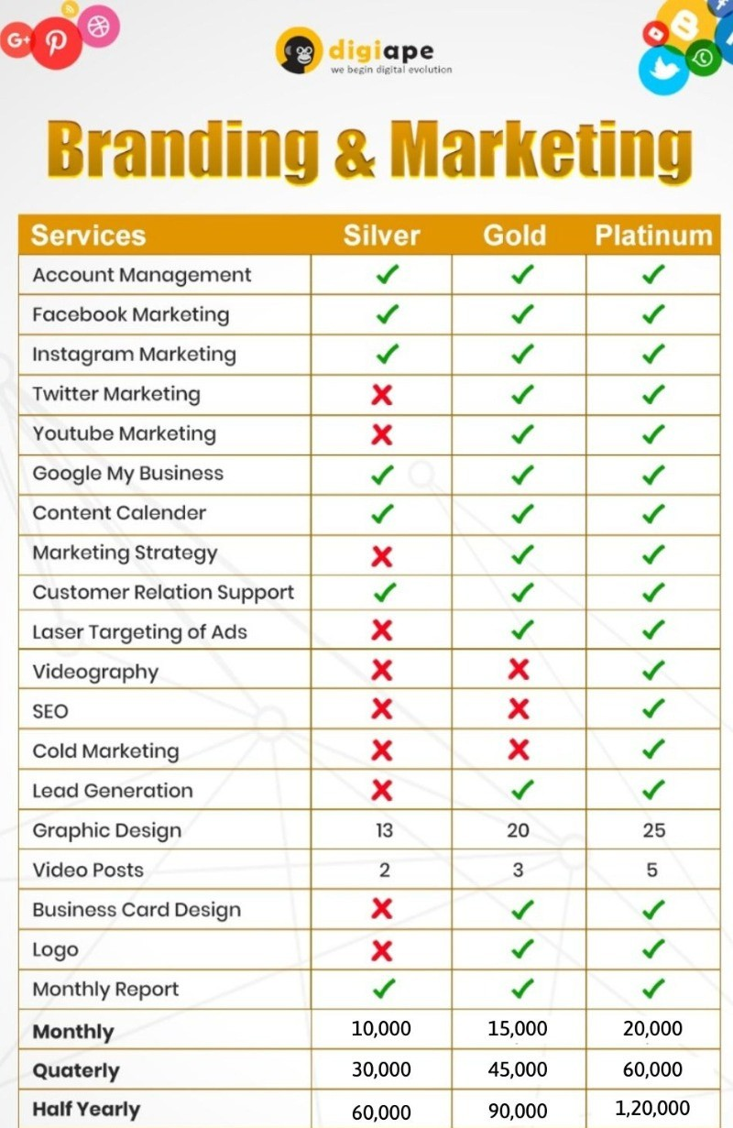

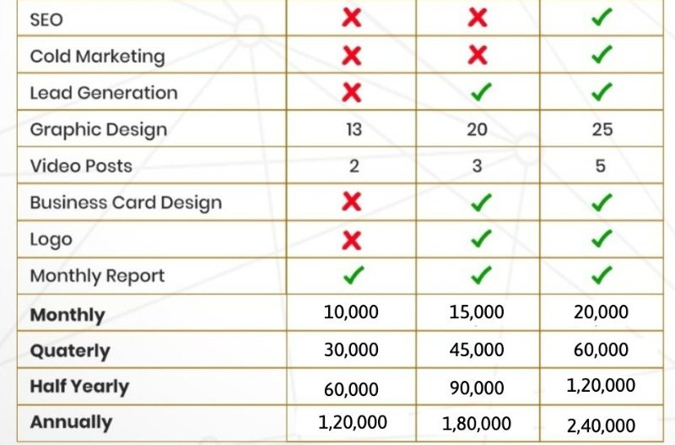

8
15
12

7,000 |  | 10,000 |  | 15,000
21,000 |  | 30,000 |  | 45,000
42,000 |  | 60,000 |  | 90,000
80,000 |  | 120,000 |  | 180,000




